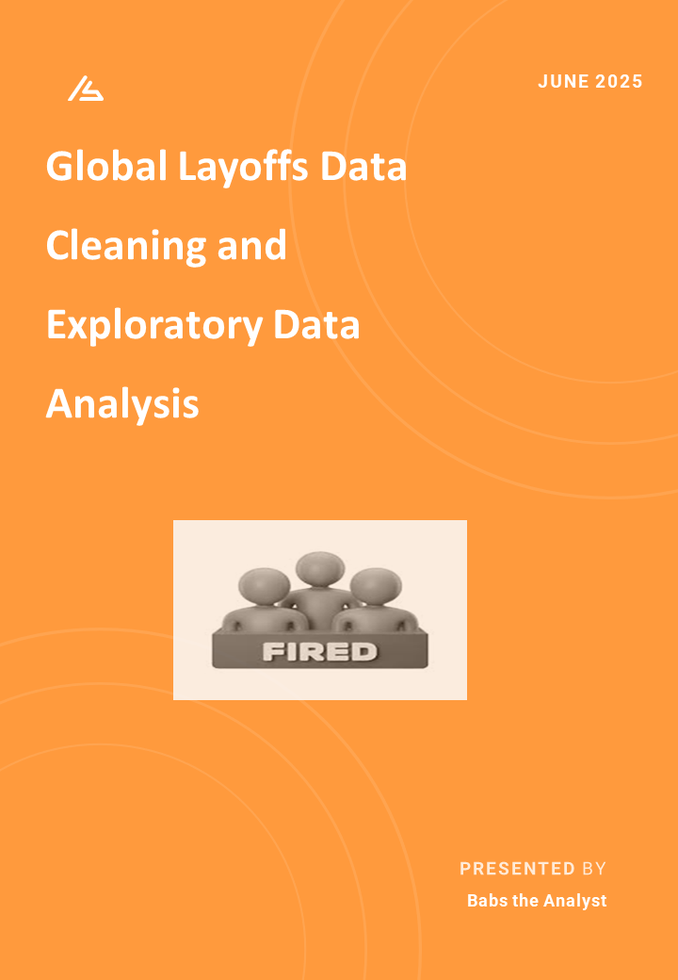
Table of Content
- Introduction
- Project Overview
- Problem statement
- Dataset overview
- Tool used
- Data cleaning Steps
- Projects Structure
- Exploratory Data Analysis
- Insights and Findings
- Final observation and insights
- Recommendations
- Conclusion
Global Layoffs Data Cleaning and Exploratory Data Analysis

- Introduction
In today’s data-driven world, organizations rely on accurate and clean data to make decisions. However, raw datasets often come with inconsistencies, duplicates, and missing values that can lead to incorrect analyses. This project aims to clean and explore a layoffs dataset, then extract actionable insights to help understand trends in layoffs across companies, industries, and geographies. It also highlights layoffs in Nigeria, offering local context within the global picture. It demonstrates practical SQL data cleaning techniques and exploratory data analysis (EDA) using advanced SQL concepts such as window functions, CTEs, and aggregation.

- Project Overview
This project involved two primary stages:
1. Data Cleaning: Standardizing and transforming raw data to ensure consistency and completeness.
2. Exploratory Analysis: Using SQL queries to reveal trends such as top companies affected, industry impacts, and temporal patterns.

- Problem Statement
The core problem was that the layoffs dataset contained:
- Duplicate records.
- Inconsistent strings and date formats.
- Missing or blank values.
- Unnecessary columns that hinder analysis.
- This made it difficult to gain accurate insights into the scale and nature of layoffs across different companies, industries, and countries. The problem was to clean and prepare the data using SQL — ensuring consistency, completeness, and reliability for analytical use.

- Dataset Overview
The dataset contains information on layoffs, including:
- Company: Name of the company
- Location: City
- Industry: Industry sector
- Total Laid Off: Number of employees laid off
- Percentage Laid Off: Proportion of workforce laid off
- Date: Layoff date
- Stage: Funding stage of the company
- Country: Country where layoffs occurred
- Funds Raised: Total funding prior to layoffs

- Tools Used
- MySQL: For data cleaning and SQL queries.
- SQL Window Functions: ROW NUMBER () for duplicate removal.
- Data Formatting Functions: STR_TO DATE (), TRIM (), GROUP BY, etc.
- CTEs (Common Table Expressions): for stepwise aggregation and rolling totals.

- Data Cleaning Steps
Here’s what was done to clean the data:
- Removed Duplicates: Used ROW_NUMBER () to identify and delete duplicate rows.
- Standardized Strings: Trimmed whitespace and fixed typos in company, industry, country.
- Formatted Dates: Converted date to proper SQL DATE format with STR_TO_DATE ().
- Filled Missing Industries: Updated blank industry fields by joining on company where information was available.
- Removed Incomplete Records: Deleted rows with both total_laid_off and percentage_laid_off as NULL.
- Dropped Unnecessary Columns: Removed helper column (row number) after deduplication.

- Project Structure
Database Setup
The cleaning begins by creating another table layoffs2 with all necessary columns with temporary row_number column is used for deduplication by removing duplicates,
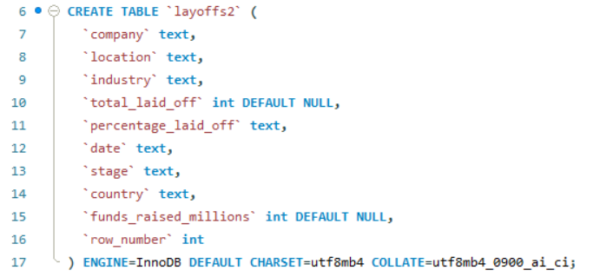
Data Cleaning Steps
Key cleaning operations in the SQL file:
- Remove Duplicates
Uses the ROW_NUMBER() function to detect and remove duplicates


- Trim Whitespace: To ensures consistent text values.

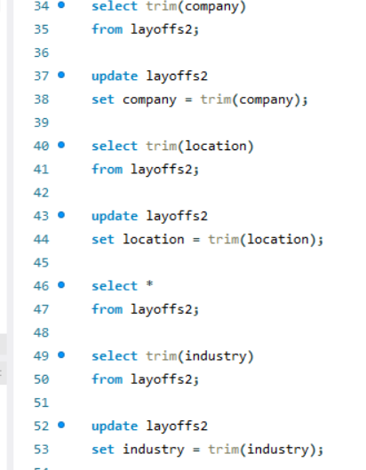
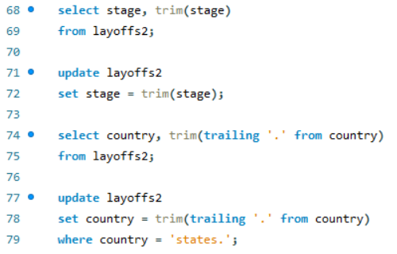
- Convert Data type: Converts string dates to SQL DATE type
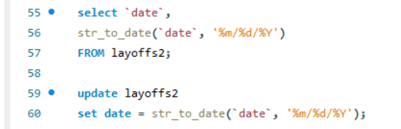


- Standardize Values and Fill Missing Data
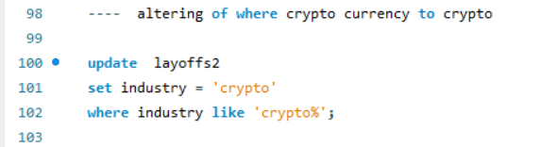
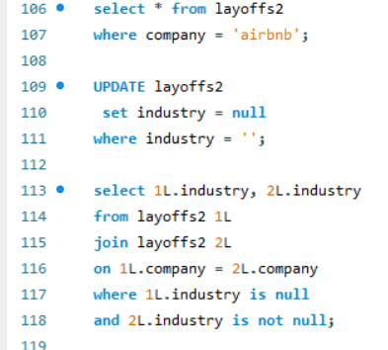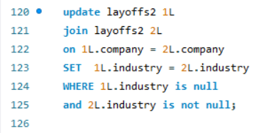

- Drop Temporary Columns
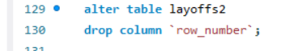

- Exploratory Data Analysis (EDA)
The second SQL file (layoff query.sql) explores layoff trends using analytical queries. Key EDA components:
- Summary using DESCRIBE and COUNT () functions.
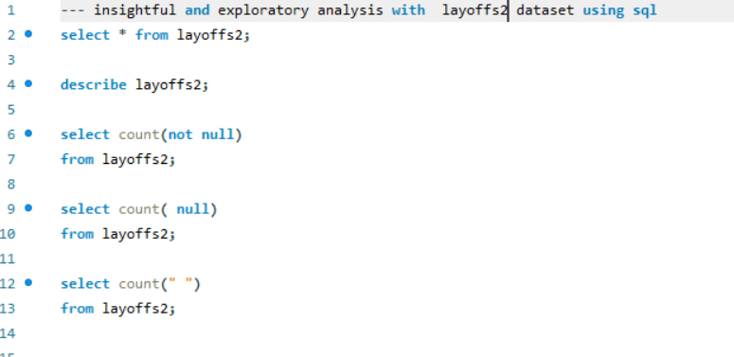
- looking at the start and the end of layoff
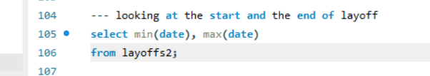
- looking at the start and the end of layoff
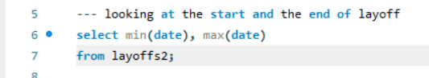

- Insight and Findings
- Top 5 maximum laid off in one day by company, location, and country.
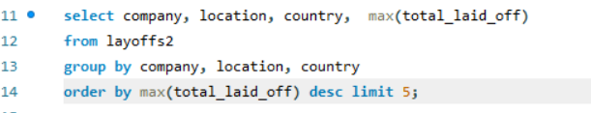
- Top 5 maximum % laid off in one day by company, location, and country.
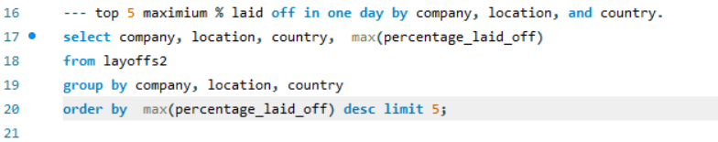

- Total laid off by Company
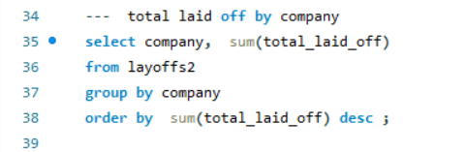

- Total laid off by industry
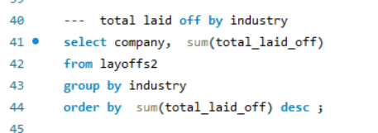

- Which country got the most during layoffs
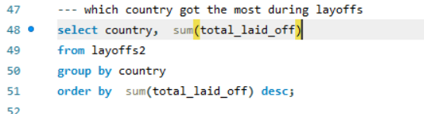

- Total layoffs by year
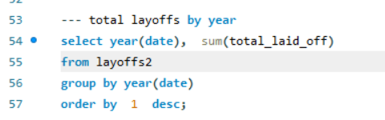

- Total layoffs by month
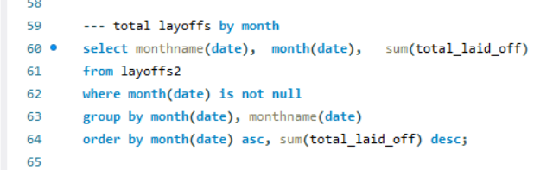

- Average % laid off by industry
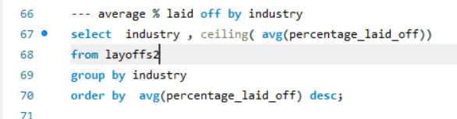
- which stage got the most during layoffs
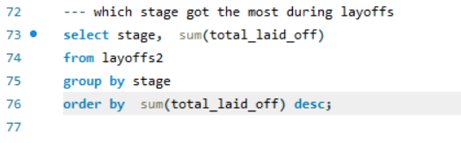

- Companies in Nigeria with layoffs
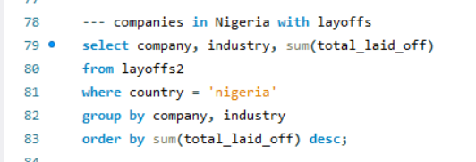

- Total layoff by year in Nigeria
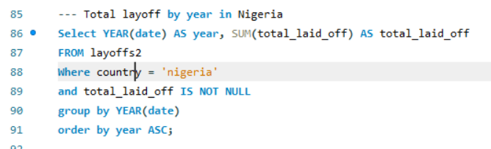

- Total layoff by month and year
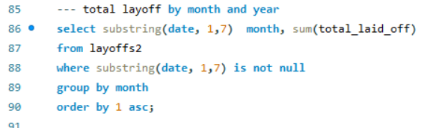

- Rolling total by month and year
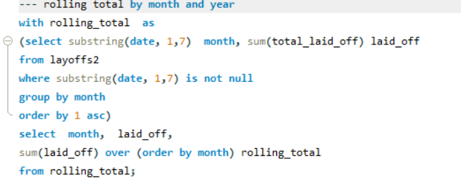

- Final Observations and Insights
Some of the most important findings include:
- Tech and consumer companies faced the most severe layoffs: These sectors consistently topped the list of total layoffs across the dataset. Layoff peaks followed macroeconomic shocks. Sharp spikes in layoffs clearly align with key events like the COVID-19 pandemic in 2020 and the funding downturns in 2022.The steepest layoffs occurred during these turbulent periods, revealing how economic instability propagates into workforce reductions.
- Rolling monthly totals highlight sustained patterns of volatility: By aggregating layoffs into monthly buckets and analyzing the rolling total. The data reveals not just one-off surges, but longer periods of elevated layoffs spanning multiple months.
- The rolling total grows rapidly after mid-2020 and mid 2022: this indicates waves of layoffs spreading across companies rather than isolated incidents. Month-over-month trends help us identify risk windows and anticipate future layoffs if similar economic conditions reoccur.
- Seasonality and clustered spikes: The data also shows seasonal patterns and clustered spikes for example like the End-of-year layoffs often rise as companies tighten budgets. Tech layoffs tend to roll into the first quarter of the next year after investors’ funding decisions.
- Industries & geographies most affected during spikes: Industries like tech, consumer internet, and retail saw disproportionate layoffs during peak months. The United States home to most major tech companies also saw the steepest absolute numbers and sharpest spikes in layoffs as compared to other countries.

In Nigeria’s Case
- 2022 recorded the highest layoffs (1,020 employees) in Nigeria, aligning with the peak in Jumia’s and Alerzo’s job cuts within the retail sector.
- The Retail industry dominates layoffs, accounting for over 1,300 cumulative job losses (Jumia and Alerzo) reflecting cost-cutting measures and market competition in e-commerce.
- The Finance sector (Renmoney, Kuda, OPay) follows, with more than 400 layoffs, suggesting restructuring among digital banking and fintech startups.
- The Transportation industry (Gokada, Bolt) faced downsizing as ride hailing operations adjusted post-pandemic.
- Crypto related firms (Nestcoin, Quidax) were also impacted, likely due to volatility in global digital asset markets.
- Smaller firms such as Vendease (Food) contributed modestly to the totals, indicating layoffs spread across multiple emerging industries.

- Recommendations
Based on the cleaned data and analysis:
- Companies and Investors: Should monitor industry-specific economic signals and diversify their funding sources to mitigate mass layoffs
- Employees: May want to focus on industries with stable or growing demand
- Analysts and HR departments: Implement regular data cleaning and tracking to proactively identify risky trends before they worsen
- Policy Makers: Should explore safety nets for heavily impacted industries and geographies.
- Macroeconomic Intervention: Address inflation, unstable exchange rates, and high logistics costs. Government should strengthen SME financing and ensure foreign exchange stability to help companies manage operational costs without job cuts.

12.Conclusion
This project demonstrated the importance of data cleaning as a critical first step before analysis. The cleaned layoffs data yielded accurate, actionable insights into global layoff patterns, helping stakeholders make better-informed decisions. Continued use of these practices will ensure organizations can respond to workforce changes with greater foresight and resilience.

